LOCAL PATIENT PARTICIPATION REPORT 2012 - 2013

- Patient Reference Group (PRG) Members Profile: This year 12 patients were part of our PRG, which is 3 more than last year due to our advertising campaign. PRG members were either involved in person at meetings or via email. The profile of the PRG is as follows:

- Sex: 42% male, 58% female
- Age: 25% 45-54, 17% 55-64, 42%65-74, 17% 75-84
- Employment: 25% Part time work, 8% Permanently Sick or Disabled, 67% retired.
- Carers: 25% are carers
- Parents: 8% parent/guardian for someone under 16 years of age
- Ethnicity: 100% British

Although this PRG does not exactly represent the practices registered patient population (as no members are under the age of 40 or from an ethnic background other than British) the group actively considers all 3024 registered patients in all its discussions. (See appendix)

- Representation in the PRG: Despite our best efforts, the PRG is not entirely representative of our practice population (See appendix). To encourage a representative PRG, new members were encouraged to join as well all members of the PRG last year. As the PRG last year had no parents/guardians, no disabled patients or any patients under 40 years old we tried to include these groups of patients in our PRG this year to make it more representative. It is positive to see that this year our PRG did include parents/guardians and disabled patients. Although no patients under 40 years old attended, they were actively invited. On 24/01/2013, 66 patients under 40 who had recently attended the Practice were sent a text message inviting them to be part of the PRG. The invitation read as follows: “SelborneRd Medical Centre invites you to be part of our PatientGroup to help identify ways we can improve. A meeting will be held at SelborneRd Medical Centre on Thursday 31/01/13 at 12.30; alternatively you can be involved via email. If you'd like to be involved please contact the surgery on 011426869292”As a result, patients from the underrepresented groups did confirm that they would attend. Unfortunately, they did not come for the meetings or get involved via email.

Further, our PRG only included patients from a British ethnic background. To try and diversify the group, the patients who were sent a text message as detailed above included patients from a variety of ethnic backgrounds including Asian, British, Chinese, Indian and others. Last year a patient from an Indian background was part of the PRG, unfortunately they were not able to be part of the PRG this year.
- Agreeing priority issues: At the meeting on 31st January 2013, the PRG discussed the issues that were a main priority to patients. The results of last year’s PRG designed patient questionnaire and the actions taken were also discussed, with the results and outcomes of that report helping to shape this year’s main priorities (for further information please see the Local Patient Participation Report 2011 – 2012). The agreed main priorities were as follows: The functions and content of our website, whether patients would like water in the waiting room, privacy at the reception desk, general satisfaction with the care provided, if the Practice would be recommended, what patients like about the surgery and what patients like and think could be different about the surgery. As well as these agreed priority areas, general questions would also be involved to ensure our response came from a cross-section of our patients. All the questions for the local practice survey were decided upon at this meeting.

- Obtaining the views of registered patients: Once the questionnaire was designed, it was handed out to patients to complete when they attended the surgery. This made sure that we had up to date responses from patients who recently accessed our services. 102 questionnaires were also posted to a random stratified sample of patients. This was done in order to try and make sure that the questionnaire was given to cross section of the registered patient community. We had around a 40% response rate from the posted questionnaires which is very high, although down from last year. In total we had 71 questionnaires completed which represents 2.4% of the practice population which is in line with previous CFEP practice questionnaire sample sizes and what was agreed with the PRG. The PRG felt that the responses were valid as they were from a cross-section of patients (see responses to questions 8-13 in section G).

- Discussing the results with the PRG: A meeting was held on 21st March 2013 to discuss the questionnaire results with the PRG. An action plan based on the results was also discussed and agreed upon. If any PRG member was unable to attend they were offered involvement via email.

- Action Plan:

- Based on the responses of what patients wanted to see on our website, it was decided that although we have the majority of what patients want, it could do with updating on a monthly basis, have extra sections for Healthy Living and Health News, as well as an area for local health news. The online appointment booking website will also be updated explaining why Nurse Appointments cannot be booked online.
- 63% of patients surveyed said they would like to have water available in the waiting room. As a result the surgery will look into what options are available. Funding may not be available for a water cooler system, but posters could be put up offering patients to ask if they need a drink. These options will be discussed with the Partner GPs.
- 17% felt that in the Reception Area, other patients can overhear what you say to the Receptionist and are not happy about it. For question 7, 13% said that they would like more privacy at the reception desk. This area was raised last year and is a problem for the majority of GP Surgeries in converted houses. The action plan from last year was implemented, namely the Life Channel TV in waiting room back was switched on to stop patients overhearing and a more prominent poster was put in the waiting room and entrance hall telling patients to inform reception if they would like a private word and they can come round to the other side of reception away from the waiting area. The Surgery discussed this with all the staff. The Life Channel TV is currently not working correctly and this has been reported to the supplier but we are still waiting for them to fix the issue. The posters will be reviewed to make sure they are visible and clear. Changing the layout of the surgery was discussed but is not currently practical. The privacy at the reception desk will be considered in any future renovations of the surgery.
- For question 7, 7% said that they would like waiting times to be improved and 7% would like to be told if the GP is running late. Last year this was brought up and it was decided that receptionists would tell patients who arrive for an appointment how many patients are waiting before them. This was implemented but seems to have now stopped. The Practice will now ensure that this is done routinely. The PRG feels that this would be a helpful service to patients.
- From question 7, 7% would like more out of office hours available. The PRG discussed the fact that we used to have an evening clinic but there was very little demand with an average of 1 patient per week. As a result this clinic was stopped as there was no demand. We do offer appointments as early as 8.30am and 6pm. The surgery currently diverts calls to an Out Of Hours service (OOH) between 12-3.30 each day and the PRG wondered if this could also be a problem for patients. The Surgery will look into the feasibility of stopping diverting calls to our OOH at lunch times and keeping calls coming through to receptionist in the surgery. However, this was considered as a result of last year’s Local Patient Participation Report and it was decided that during these times we often have only 1 receptionist working and if the phones were not diverted then there may staffing issues as the jobs set aside for that time period may not be completed if we were taking calls. Funds were not available to increase staffing levels during these times. The PRG were sympathetic with this.

- Statistical evidence: These are the results of the Patient Questionnaire:

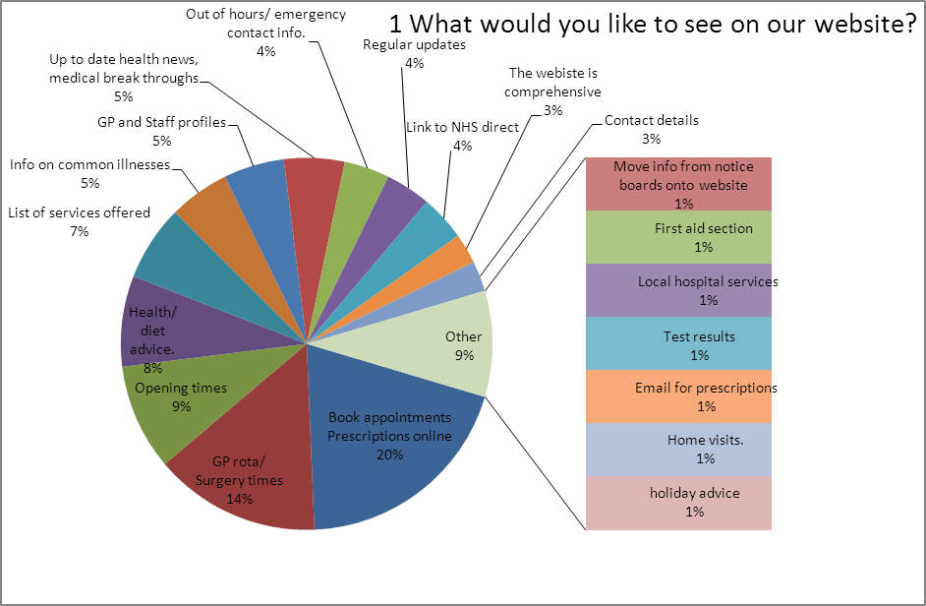

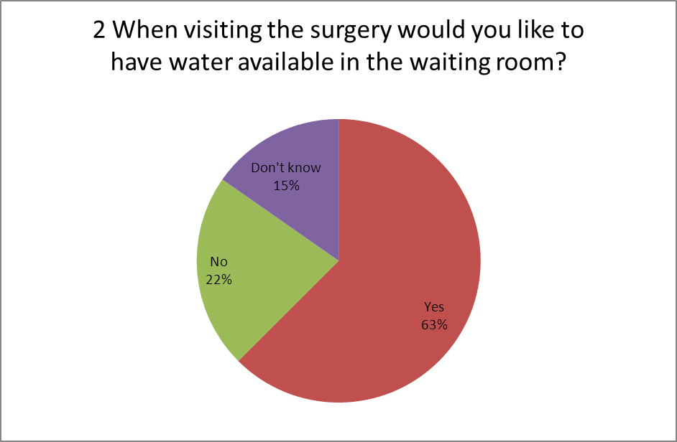

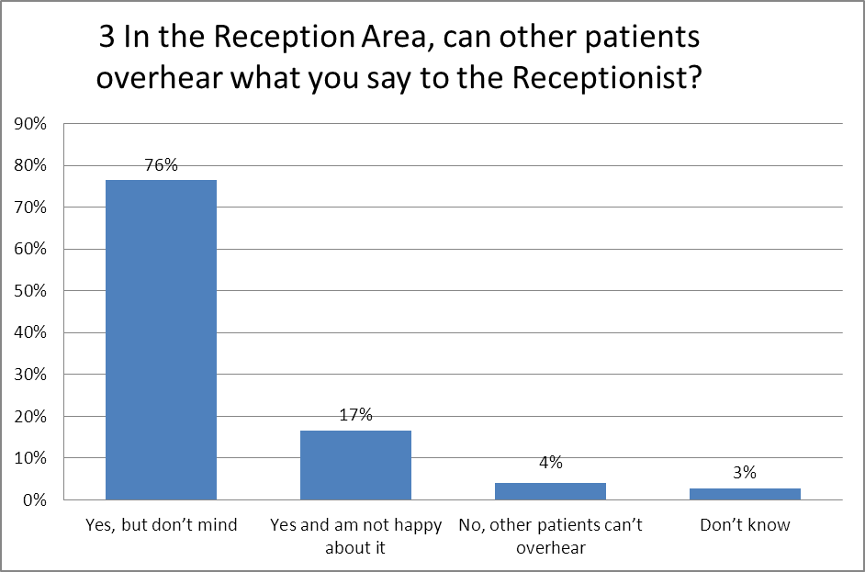

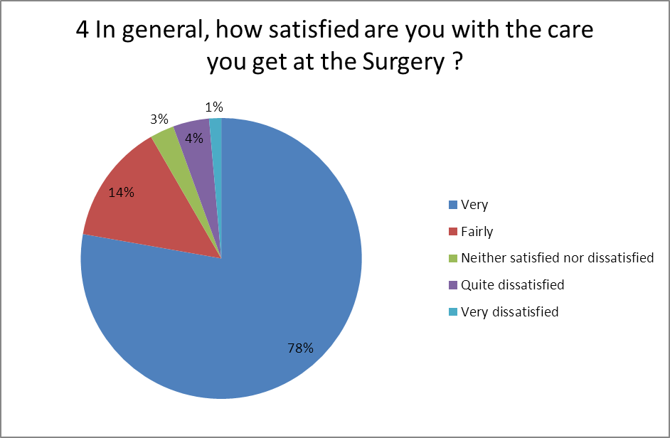

4b What would make you more satisfied? | No.
Reduced appointment waiting times | 7
we are very satisfied | 3
The GP looks up symptoms on a website, I could do that. | 1
More Out of hours slots | 1
Earlier appointments | 1
late evening GP appointments | 1
Dr Morris taking more surgeries | 1
Make appointments with Nurse online | 1
ability to contact surgery by phone between 12-3.30 | 1
phones answered promptly | 1
Being kept up to date with how late a clinic is running | 1
repeat prescriptions available within 25h not 48h | 1
post days clinics in centre | 1
More time with GPs | 1
Ordering prescriptions for family online | 1
For the GPs to listen | 1
more friendly reception staff (feels like us and them) | 1
Receptionists phone back when they say they will | 1
Getting an appointment | 1

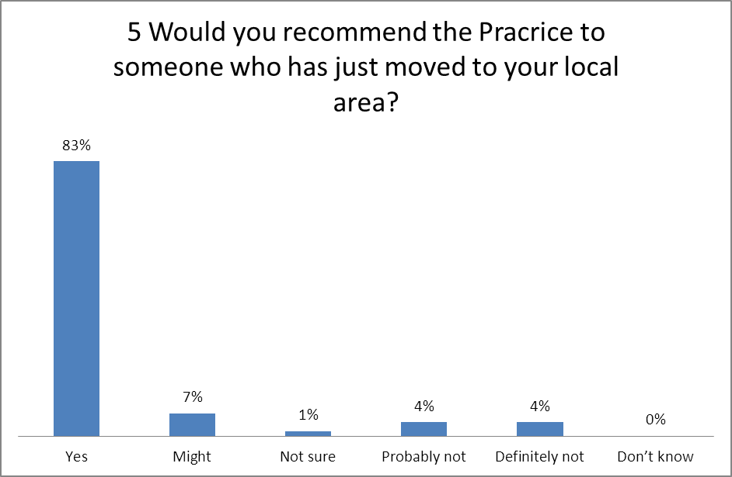

5b if not why?
Just seems to give lip service…we need real doctors
frequent changes of Doctors
not referred to hospital in time for operation
long waiting times after appointment made, very unhappy with a particular GP who was a locum

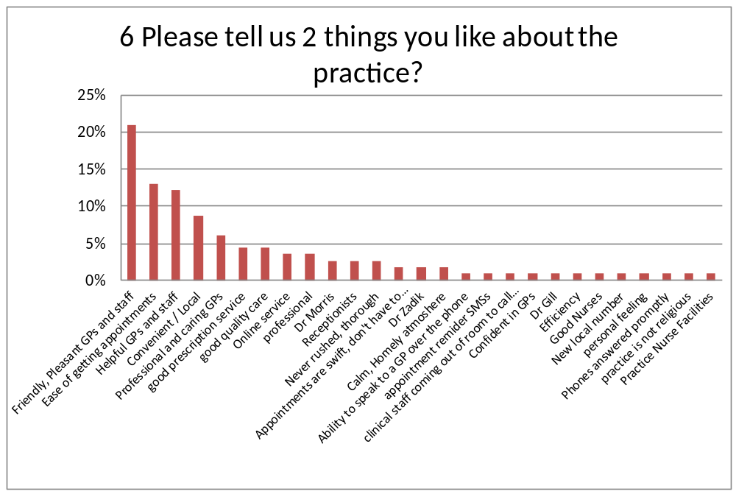

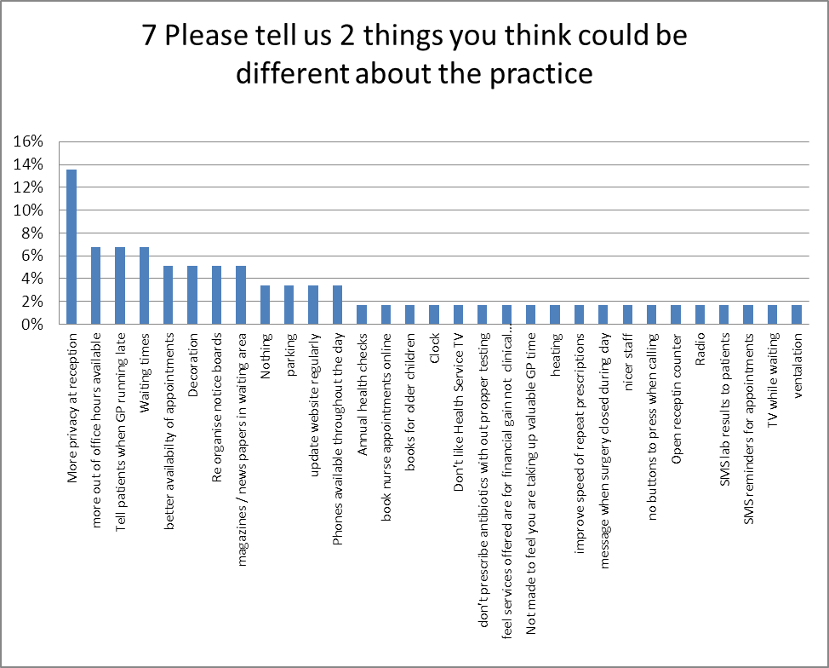

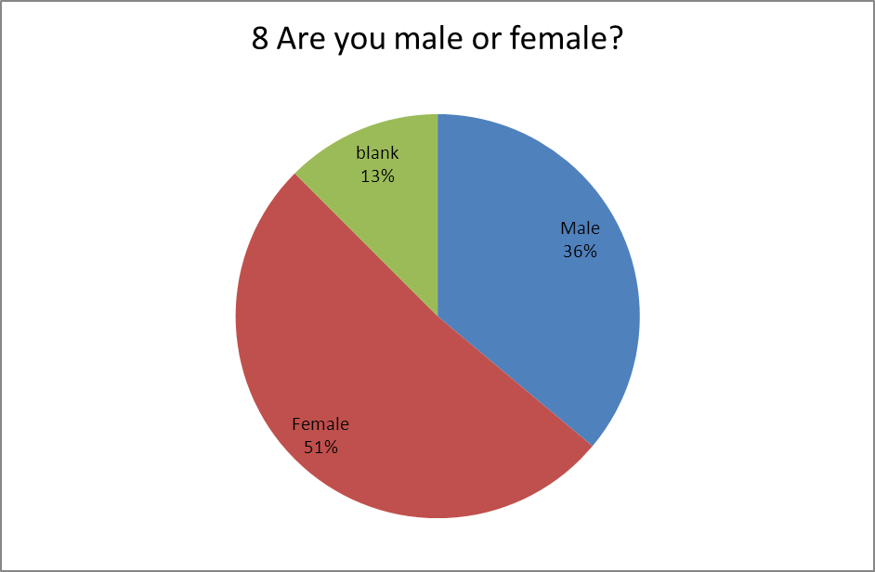

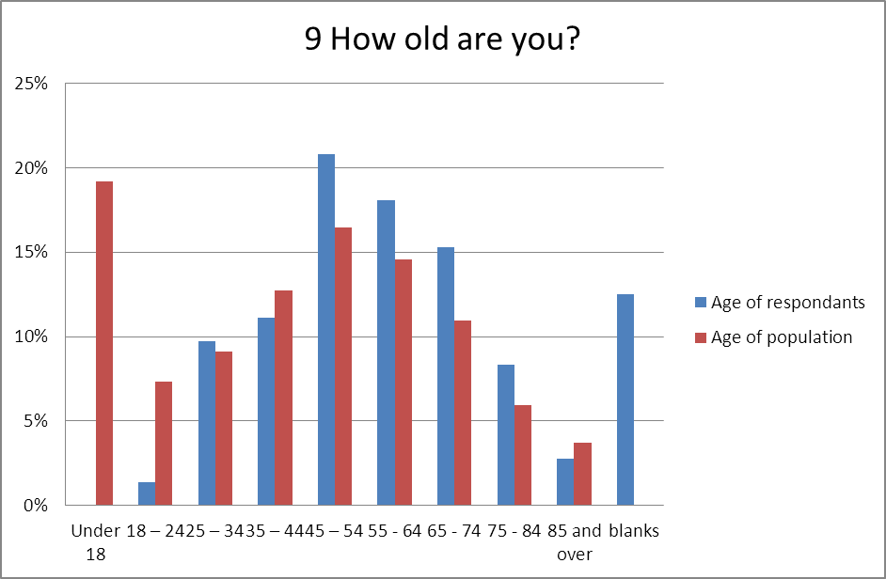

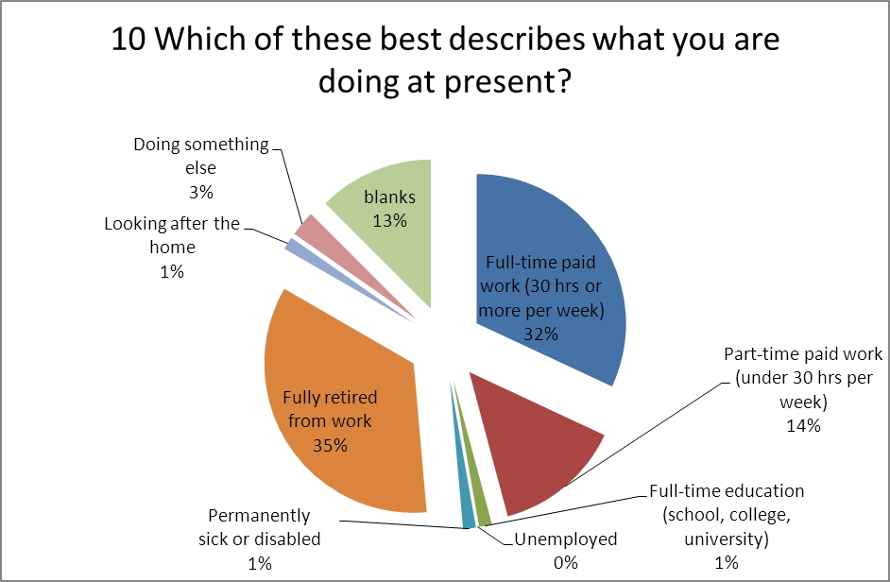

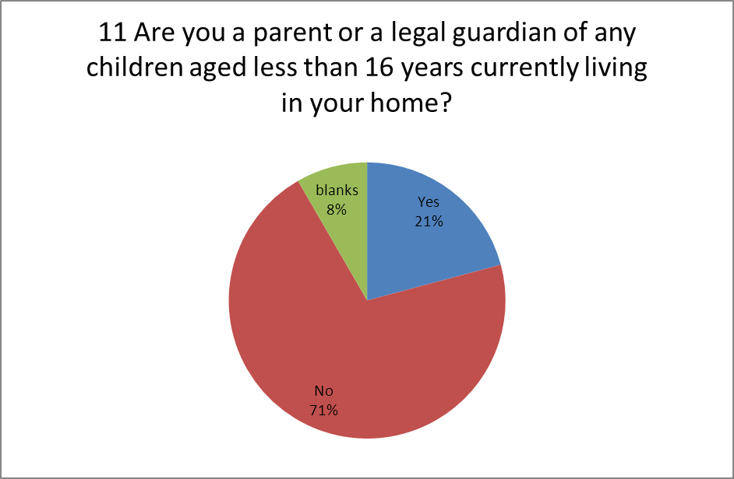
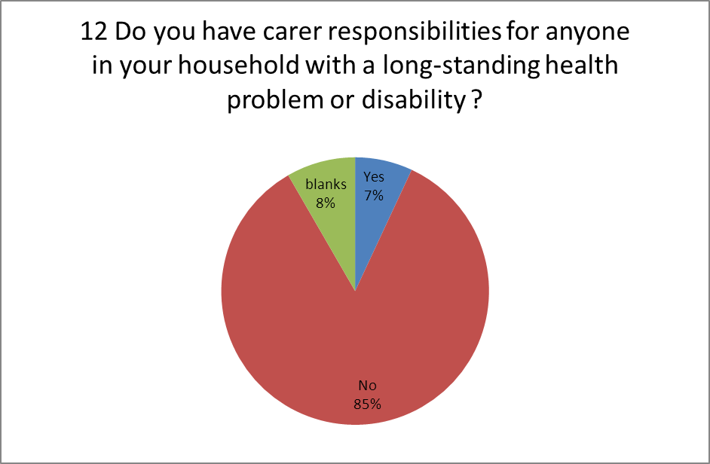
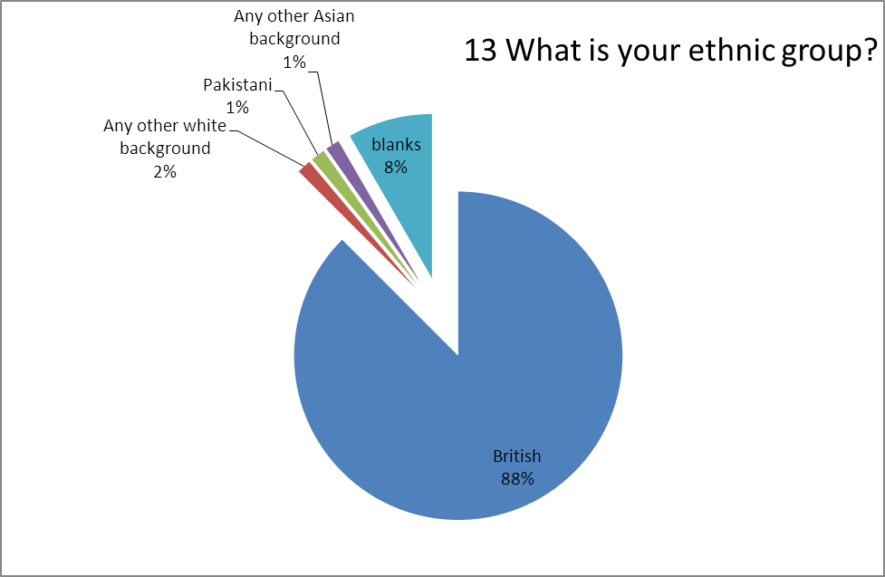
Comments
Excellent service
I am very satisfied with the service
I am very satisfied with the practice
No experience of OOH service or Home Visit
Thank you for all the care over the years
I don't visit much but when I do I am generally satisfied
I am very happy with care given by all staff. Our family has no complaints
Continued improvement
- Details of Action:
- Make a member of the Practice Team responsible for updating the website at least on a monthly basis by 31st March 2013. Add this to their Job Description. In April 2013, add new areas to the site promoting healthy living, health news and local health issues. Update the Online Booking System to explain that Nurse Appointments aren’t available to book online due to the appointment lengths varying depending on what the appointment is for.
- In April 2013 discuss with the GP partners the options of having water available for patients in the waiting room. If a water cooler can’t be provided, discuss whether staff give patients water if patient is unwell and put up a poster advertising this.
- The Life Channel TV Company will be contacted again before 31st March 2103 to fix the TV. By 31st March 2013, check the posters informing patients of where to go if they want more privacy with a receptionist, improve or reposition them if necessary.
- By 31st March2013 instruct all receptionists to inform patients how many people are waiting to see the GP/Nurse/HCA before them. This is to be done routinely for all patients.
- During April 2013 the GP Partners will discuss staffing levels between 12-3.30pm and will consider the possibility of taking calls during these times.

- Opening Hours: The surgery is open from 8.30am to 6.00pm Monday to Friday (the building does not close at lunch times), except on Thursdays when we are open 8.30am to 1pm. The telephone lines are open 8.30am to 12 noon and then again 3.30pm to 6.00pm Monday to Friday, except Thursday when the lines are only open 8.30am to 12 noon. If you call outside of these hours your call will be forwarded to our Out Of Hours service provider. Appointments can be made by telephone, in person at reception or through the Internet. Repeat prescription requests can be made in person, by post using the white side of your previous prescription, by telephone, by fax, via a pharmacy or through the Internet. Signed prescriptions will be ready 2 days later and can be collected, posted out if a SAE is provided by the patient or patients can arrange for a local Pharmacy to collect prescriptions on their behalf.

- Extended Hours Access Scheme: We no longer provide Extended Hours Access due to extremely low demand for appointments when it was available.

This Report has been made available to everyone from 27th March 2013 at:

www.selborneroadmedicalcentre.co.uk
Appendix
Practice Population Profile

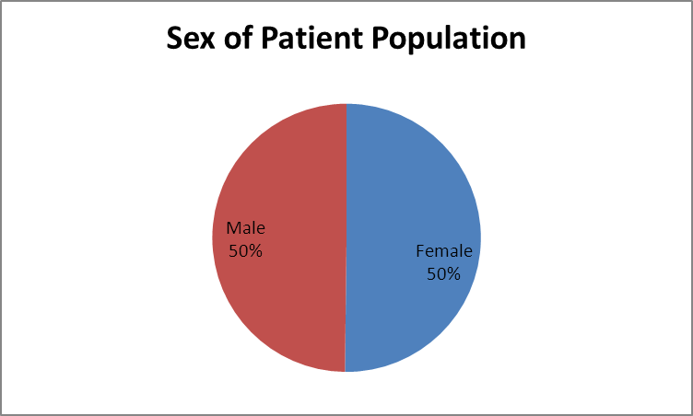

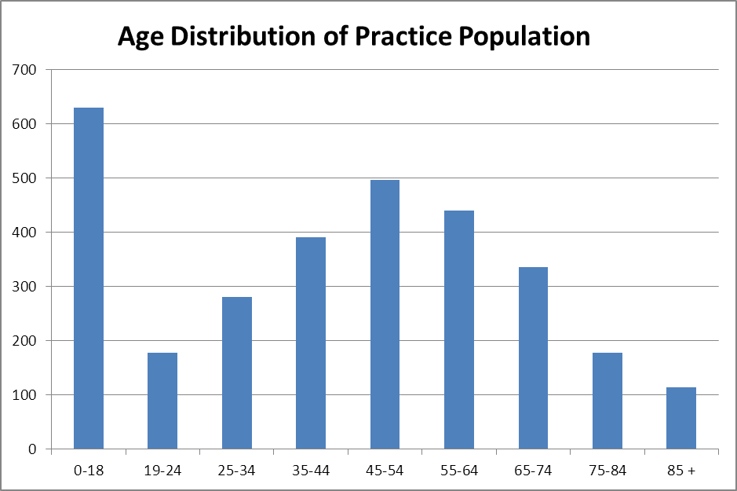
Note: Although we do not record patients who are parents using readcodes, the high number of Children under 18 show us that there is a larger proportion of parents in our practice population.
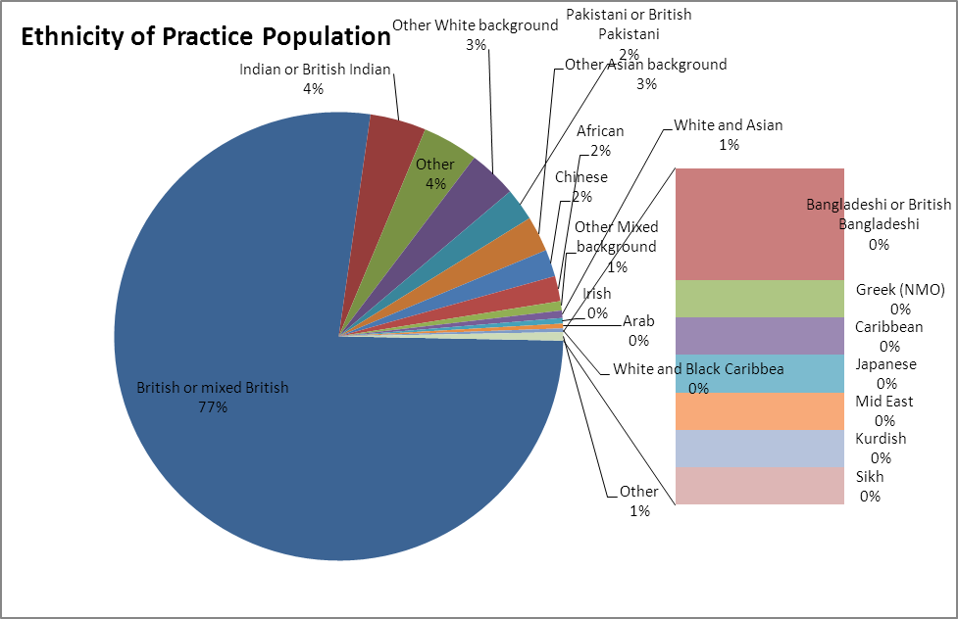
*Note: Patients with no ethnicity recorded were removed from this chart. This chart represents the 54% of patients for whom we have ethnicity recorded. Recording ethnicity is something we routinely do in practice and when registering patients so as to improve our record.

Carers: 2% of our practice population are recorded as being carers.

Employment status: We do not routinely record employment status of patients as it is not clinically relevant.

